Compound word

🟢 What is a Compound Word?
# Source: AI Source: Provided by: [Data Path: Persons Table -> ID Column: 1, Name_En Column: Motasem Essam] -> From: [Chatgpt (GPT-4-turbo)] on [7/24/2025]
A compound word is made by joining two or more words together to form a new word with a unique meaning.

📘 Definition:
# Source: AI Source: Provided by: [Data Path: Persons Table -> ID Column: 1, Name_En Column: Motasem Essam] -> From: [Chatgpt (GPT-4-turbo)] on [7/24/2025]
A compound word is a word formed when two or more root words are combined to create a new word with a single meaning.

🧠 Types of Compound Words:

✅ Main Types of Compound Words (Based on Form)
# Source: AI Source: Provided by: [Data Path: Persons Table -> ID Column: 1, Name_En Column: Motasem Essam] -> From: [Chatgpt (GPT-4-turbo)] on [7/24/2025]
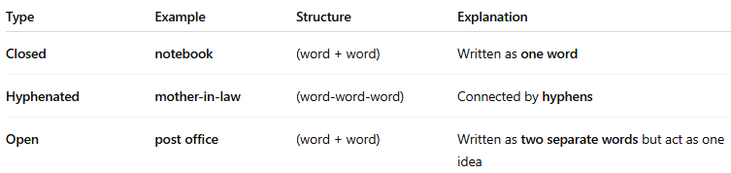
Type | Example | Structure | Explanation
Closed | notebook | (word + word) | Written as one word
Hyphenated | mother-in-law | (word-word-word) | Connected by hyphens
Open | post office | (word + word) | Written as two separate words but act as one idea

✅ Types of Compound Words by Part of Speech
# Source: AI Source: Provided by: [Data Path: Persons Table -> ID Column: 1, Name_En Column: Motasem Essam] -> From: [Chatgpt (GPT-4-turbo)] on [7/24/2025]
Many compound words function as nouns, but there are also compound verbs, adjectives, etc.
Here are the types that are compound nouns:

🔹 1. Noun + Noun → Compound Noun
# Source: AI Source: Provided by: [Data Path: Persons Table -> ID Column: 1, Name_En Column: Motasem Essam] -> From: [Chatgpt (GPT-4-turbo)] on [7/24/2025]
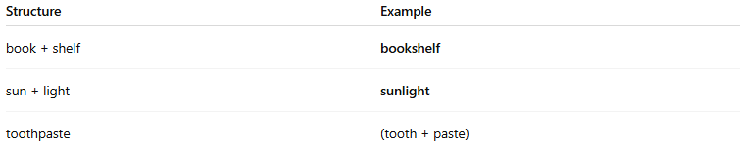
Structure | Example
book + shelf | bookshelf
sun + light | sunlight
toothpaste | (tooth + paste)

🔹 2. Adjective + Noun → Compound Noun
# Source: AI Source: Provided by: [Data Path: Persons Table -> ID Column: 1, Name_En Column: Motasem Essam] -> From: [Chatgpt (GPT-4-turbo)] on [7/24/2025]
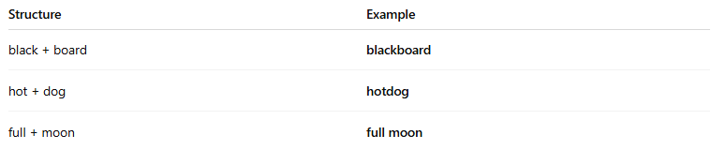
Structure | Example
black + board | blackboard
hot + dog | hotdog
full + moon | full moon

🔹 3. Verb + Noun → Compound Noun
# Source: AI Source: Provided by: [Data Path: Persons Table -> ID Column: 1, Name_En Column: Motasem Essam] -> From: [Chatgpt (GPT-4-turbo)] on [7/24/2025]
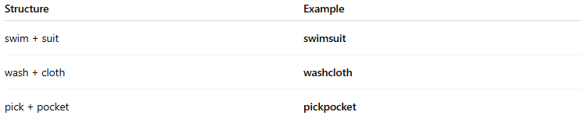
Structure | Example
swim + suit | swimsuit
wash + cloth | washcloth
pick + pocket | pickpocket

🔹 4. Noun + Verb (or verb-ing) → Compound Noun
# Source: AI Source: Provided by: [Data Path: Persons Table -> ID Column: 1, Name_En Column: Motasem Essam] -> From: [Chatgpt (GPT-4-turbo)] on [7/24/2025]
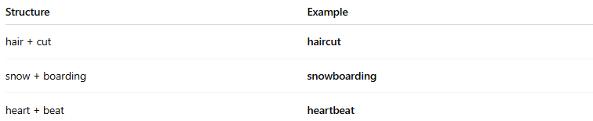
Structure | Example
hair + cut | haircut
snow + boarding | snowboarding
heart + beat | heartbeat

🔹 5. Verb + Preposition / Adverb → Compound Noun
# Source: AI Source: Provided by: [Data Path: Persons Table -> ID Column: 1, Name_En Column: Motasem Essam] -> From: [Chatgpt (GPT-4-turbo)] on [7/24/2025]
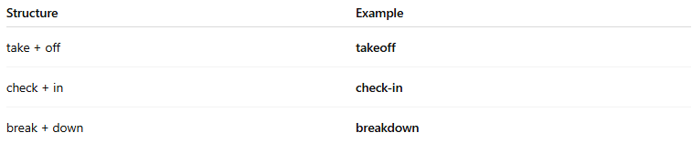
Structure | Example
take + off | takeoff
check + in | check-in
break + down | breakdown

✅ Summary: Compound Noun Structures
# Source: AI Source: Provided by: [Data Path: Persons Table -> ID Column: 1, Name_En Column: Motasem Essam] -> From: [Chatgpt (GPT-4-turbo)] on [7/24/2025]
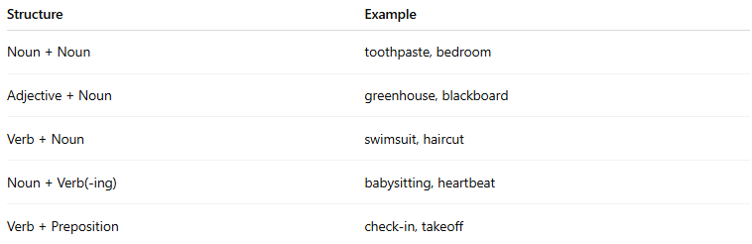
Structure | Example
Noun + Noun | toothpaste, bedroom
Adjective + Noun | greenhouse, blackboard
Verb + Noun | swimsuit, haircut
Noun + Verb(-ing) | babysitting, heartbeat
Verb + Preposition | check-in, takeoff

✳️ Examples of Compound Words:
# Source: AI Source: Provided by: [Data Path: Persons Table -> ID Column: 1, Name_En Column: Motasem Essam] -> From: [Chatgpt (GPT-4-turbo)] on [7/24/2025]
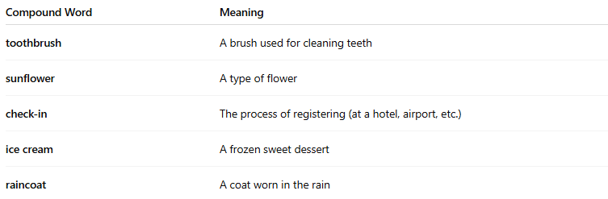
Compound Word | Meaning
toothbrush | A brush used for cleaning teeth
sunflower | A type of flower
check-in | The process of registering (at a hotel, airport, etc.)
ice cream | A frozen sweet dessert
raincoat | A coat worn in the rain

🆚 Compound Word vs Simple Word:
# Source: AI Source: Provided by: [Data Path: Persons Table -> ID Column: 1, Name_En Column: Motasem Essam] -> From: [Chatgpt (GPT-4-turbo)] on [7/24/2025]
- Simple word: One root, cannot be split (e.g. cat, blue)
- Compound word: Two or more roots joined together (e.g. bluebird, keyboard)

✅ Summary:
# Source: AI Source: Provided by: [Data Path: Persons Table -> ID Column: 1, Name_En Column: Motasem Essam] -> From: [Chatgpt (GPT-4-turbo)] on [7/24/2025]
A compound word is created when two or more words are combined to make a new word with a single meaning.

